10/13/2013

Orange Team 6:

*Team Lead:* Phillip Domschke

*Other Contributors:* Jake Frost, Wesley Ledebuhr, Steve Neola, and Marc Zimmerman

**HURRICANE PUMP ANALYSIS, PART 3**

# TABLE OF CONTENTS

TABLE OF CONTENTS 1

EXECUTIVE SUMMARY 2

ANALYSIS 3

Assessing Failure Classifications 3

Assessing Motor Failure 3

Distribution Selection 3

Accelerated Failure Time Models…………………………………………………………………………………………………………4

CONCLUSION 5

# 

# EXECUTIVE SUMMARY

We were asked by the Steering Committee of the Center for Risk Management to conduct a survival analysis on 771 pump stations in the gulf coast region during hurricane Katrina. Specifically, we were asked to investigate pumps that failed due to specific malfunctions and in turn discover the factors that contribute to those errors. These predictors should be used to assess current pumps on the Gulf Coast and replace or upgrade to prevent future failures.

|  |  |  |  |
| --- | --- | --- | --- |
| **Malfunction** | **Significant Predictors** | | |
| Flood | Backup | Servo | Slope |
| Motor | Slope | Age |  |
| Surge | Age |  |  |
| Jammed | Elevation | Slope | Age |

# ANALYSIS

## Assessing Failure Classifications

Prior to any modeling, we assessed the four failure classifications to decide if any of the errors could be clustered together for more concrete analysis. Using Cox regression models and a Likelihood Ratio test we specifically looked at combining motor and surge failures. Although these two failure types have statistically similar survival curves (Appendix), our tests reveal that they should not be combined into one failure type because of the difference in information contributing to each type. A Likelihood Ratio Test comparing a separate model for each error with a combined model yielded a chi square statistic of 163.13 (p-value < 0.0001) and 6 degrees of freedom. This indicates that the models are not statistically similar and therefore motor and surge errors should not be combined for analysis. For the rest of this report we analyzed each malfunction separately to discover what factors contributed to modeling their survivability.

## Assessing Motor Failure

Motor failure is a common malfunction among Gulf Coast pumps. We tested to see if overworking the pumps contributed to increased occurrences of motor failure. Specifically, we identified all of the pumps that died due to motor failure directly after working for 12 consecutive hours. There were 134 such pumps. Each of these was assigned a new variable called LongRun. However, this variable was not significant at an alpha level of 0.03 (p-value = 0.1680) and therefore employees for the Army Corp of Engineers do not have to worry about overworking the pumps during a hurricane. Turning the pumps on and off versus consecutive work hours does not provide a significant boost in survival time for these mechanisms.

## Distribution Selection

By comparing Likelihood Ratio Tests and several graphical goodness of fit tests (Appendix), we assessed Exponential, Weibull, Log Normal, and Generalized Gamma distributions for each of the malfunctions to find which was the most appropriate. These tests directly compare each distribution to another one so we performed three such tests for each of the four models with the following results:

|  |  |
| --- | --- |
| **Malfunction** | **Distribution** |
| Flood | Weibull |
| Motor | Weibull |
| Surge | Generalized Gamma |
| Jammed | Log Normal |

## Accelerated Failure Time (AFT) Models

# After all of the above preliminary analysis, we built models for each of the four malfunction types. These models predict how long a pump will survive (in terms of hours after a hurricane strikes) based on individual characteristics of each mechanism. The provided data assumes that each pump can only undergo at most one malfunction, so we were able to assess what characteristis specifically affect each error type.

For flooding errors, a backup system (p-value=0.0283), a servomechanism (p-value=0.0031), and the slope (p-value=0.0005) of the surrounding area around the pump are the significant predictors of survival time. The Army Corp of Engineers cannot do anything about the slope of the ground but upgrades to the backup system and servomechanism can lengthen the lifetime of a Gulf Coast pump. For more information on this error type see our previous analysis part 2.

For motor malfunctions, slope (p-value<0.0001) and age (p-value<0.0001) of the pump are the significant predictors. Besides investing in replacing old pumps, there is nothing the Army Corp of Engineers can do to significantly upgrade the resistance of pumps to motor failure.

With surge errors, age (p-value<0.0001) of the pump is the only significant predictor. For each year older a pump is, its survival time is on average 17.93% shorter. Again, replacing older pumps is the only way to significantly improve the survivability of pumps that would encounter this malfunction.

Lastly, for jamming malfunctions, elevation of the pump (p-value<0.0001), slope (p-value<0.0001), and age (p-value<0.0001) are the significant predictors. The steeper the surrounding area is around the pump, the shorter the survival time for pumps encountering jamming errors.

Conclusion

By building unique models for each of the classified error types, we have identified what characteristics of Gulf Coast pumps directly contribute to the survival time in hours of a pump’s lifespan during a hurricane similar to Hurricane Katrina. Upgrading the backup and servomechanism systems yields a significant increase in survival time for pumps in flood conditions. Running a motor for 12 hours consecutively does not significantly increase a pump’s chances of motor failure and thus the Army Corp of Engineers does not have to worry about overworking the mechanisms. Lastly, for many of the errors age is a significant predictor of survival time implying that replacing older pumps may often be the best way to upgrade the system and ensure the longest possible survival times for hurricane relief.

Appendix

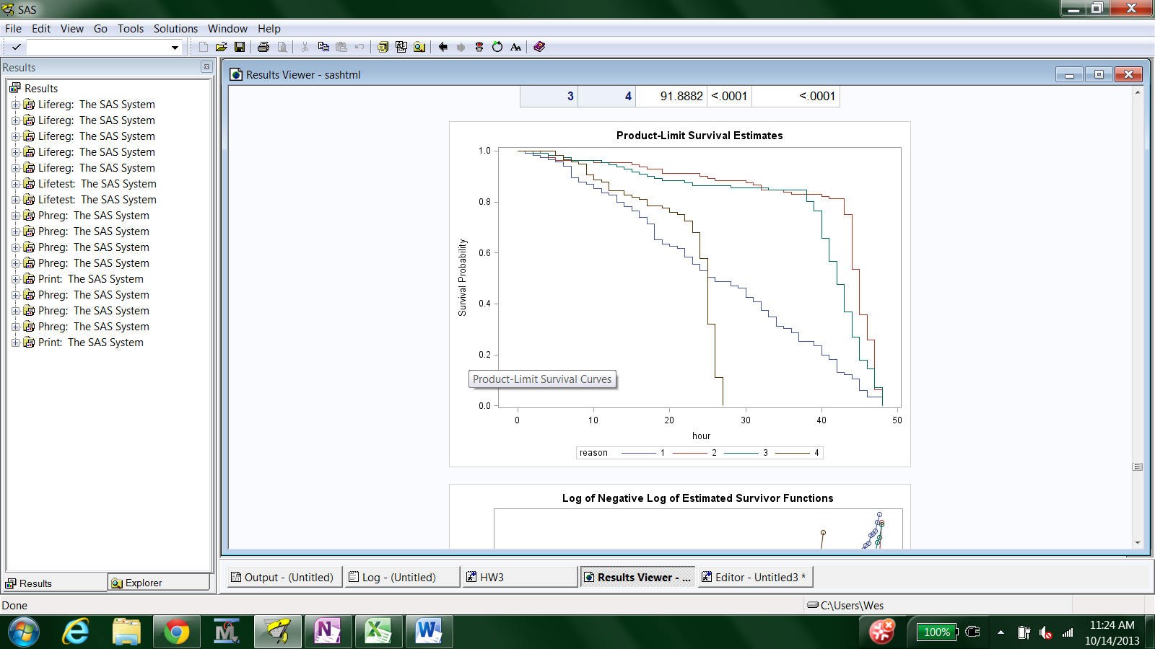Original Survival Curves for the four failure types to compare whether or not to group by type. Failure types 2 (motor failure) and 3 (surge) have curves that are statistically similar. However, they are not combined because of the difference in information leading to each failure type.

Graphical Goodness of Fit test: Using Likelihood Ratio Tests, the Generalized Gamma distribution was the preferred distribution for the motor failure model. However, this model did not converge and therefore we consulted graphical tests to compare Weibull and Log Normal distributions. The plots are shown here to illustrate our choice of the Weibull distribution. The blue plot (on bottom) tests the Weibull and the red plot (on top) tests the Log Normal.

